Abstarct:-
This project focuses on generating Pulse Width Modulation (PWM) signals using an Arduino Uno to control a relay system on an ATmega328P (Arduino Pro Mini). The PWM frequency, ranging from 1 Hz to 10,000 Hz, is generated by the Arduino Uno and transmitted to the ATmega328P. The receiving microcontroller monitors the incoming PWM signal, and based on specific frequency thresholds, triggers a relay. When the PWM frequency is within the range of 2000 Hz to 3000 Hz, the relay activates. If the frequency exceeds or falls below this range, the relay deactivates. This project demonstrates an effective method for frequency-based control systems using microcontrollers and PWM modulation, applicable to various automation and control scenarios.

Contents:-
1.Introduction……………………………………………………………………………………………………………….. 1
2. Software using …………………………………………………………………………………………………………… 2
3.Equipments Required…………………………………………………………………………………………………….. 3
4. Hardware Interfacing Equipments…………………………………………………………………………………. 8
4a)Pwm Generator……………………………………………………………………………………………………………. 8
4b) Harwdare interfacing of pwm generator and receiver ………………………………………………… 9
5.PWM Output…………………………………………………………………………………………………………………….. 10

1.Introduction.
Pulse Width Modulation (PWM) is a technique commonly used in electronics to control power delivered to devices by varying signal frequency. In this project, we use PWM signals generated by an Arduino Uno to control a relay through an ATmega328P (Arduino Pro Mini). The Arduino Uno produces PWM signals with frequencies ranging from 1 Hz to 10,000 Hz. These signals are sent to the ATmega328P, which monitors the frequency in real-time.
The system is designed to activate a relay when the PWM frequency is between 2000 Hz and 3000 Hz. If the frequency is outside this range, the relay automatically turns off. This provides a simple yet powerful way to control devices based on frequency, making it suitable for applications like motor speed control, lighting dimmers, or automated switching systems. The project showcases how microcontrollers can communicate and manage complex tasks using PWM signals.

2.Software using.

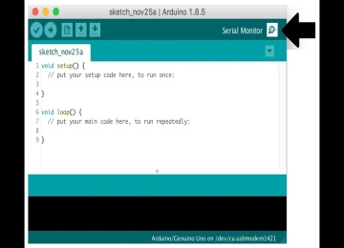
Arduino IDE software . Serial monitor for output data.

IDE software shortcuts are essential tools that help users work more efficiently by speeding up common tasks and reducing the need to navigate through menus. They allow quick file management (like creating, saving, and closing files), easy text editing (undoing, copying, and pasting), and fast navigation through large codebases (searching, jumping to specific lines or functions). Code editing shortcuts simplify commenting, formatting, and moving code blocks, while running and debugging shortcuts help set breakpoints, step through code, and start or stop programs easily. Additionally, terminal shortcuts enable quick access to command-line interfaces, and window management shortcuts allow for smooth transitions between different parts of the workspace. Overall, using these shortcuts enhances productivity and helps developers focus on writing and refining code.

3 Equipments Required.
- Arduino Uno
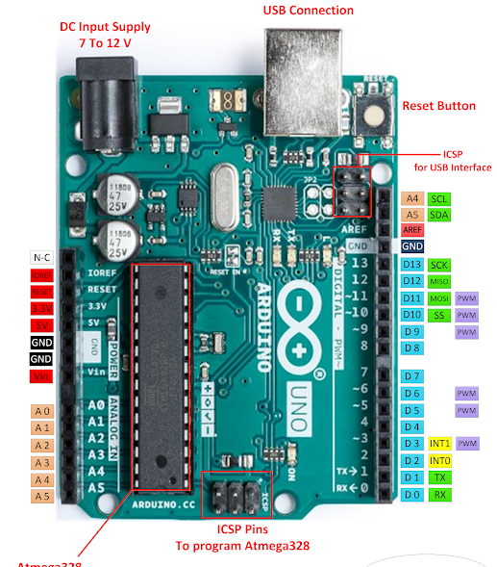
Fig:- Arduino uno board.
The Arduino Uno is a popular and easy-to-use microcontroller board designed for beginners and professionals in electronics and programming. Built around the ATmega328P microcontroller, the Arduino Uno serves as the brain of many DIY projects and systems. It has 14 digital input/output pins, 6 of which can produce PWM signals, and 6 analog input pins, which allow it to interact with a wide variety of sensors, motors, lights, and other components.

The board can be powered either through a USB connection or an external power supply, making it flexible for different project setups. Its simplicity lies in the Arduino IDE, which allows users to write, upload, and test code easily. The Uno is widely used in educational, hobbyist, and professional settings for projects like controlling LEDs, motors, sensors, and building IoT devices. Overall, the Arduino Uno is a versatile platform for learning and building a variety of electronics projects.

- ATmega328p (Mini pro).
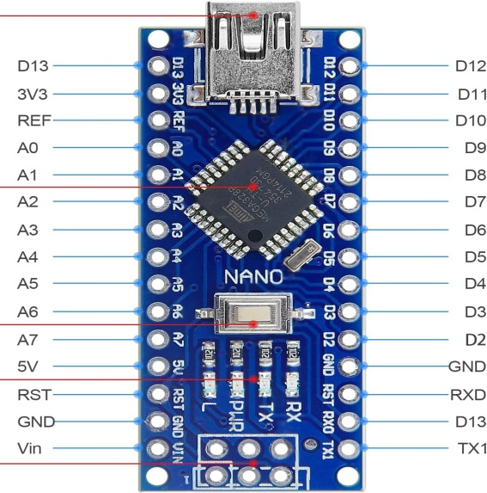
Fig:-ATmega328p(Mini pro).
The ATmega328P Mini Pro(commonly known as the Arduino Pro Mini) is a compact, low-power microcontroller board that is based on the same ATmega328P chip used in the Arduino Uno. Designed for more permanent or space-constrained projects, it provides the core functionality of an Arduino Uno but in a much smaller and lighter form factor, without onboard USB connectivity.

The Pro Mini features 14 digital input/output pins (6 of which support PWM), 8 analog input pins, and operates at either 3.3V or 5V, depending on the version. Its small size makes it ideal for embedding into projects that require limited space, such as wearable electronics, remote sensors, or other compact devices.
Since it lacks a built-in USB port, you'll need an external FTDI USB-to-Serial adapter to program it via the Arduino IDE. This board is often used by more experienced users for custom projects, prototyping, or when size and power efficiency are critical factors. Despite its size, the ATmega328P Mini Pro delivers the full capability of the ATmega328P chip, offering flexibility in small-scale, low-power projects.

- Single Channel Relay.

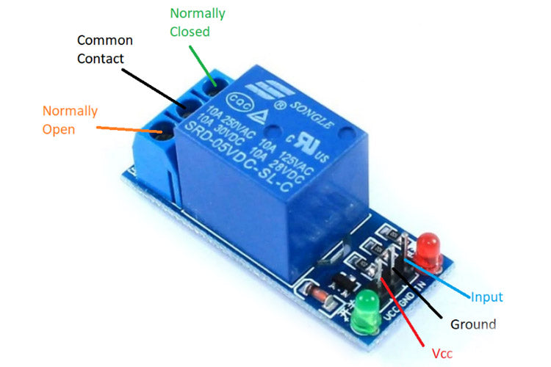
Fig :- Single channel Relay.
In this project, the relay is designed to turn on only when the frequency generated by the Arduino is between 2000 Hz and 3000 Hz. If the frequency is outside this range, the relay will remain off.
Here’s how it works: When the Arduino generates a PWM signal, it constantly monitors the frequency. If the frequency is within the range of 2000 Hz to 3000 Hz, the relay will switch on, allowing power to flow to the connected device (like a motor or light). This means the device will be powered and running only when the frequency falls within this specific range.
If the frequency goes below 2000 Hz or above 3000 Hz, the relay turns off, cutting the power to the device and stopping its operation. This behavior ensures that the connected device operates only under the desired conditions, making the relay act as a safety or control mechanism based on frequency input.
In simple terms, the relay acts like a gate, turning on power when the frequency is between 2000 Hz and 3000 Hz, and keeping it off at any other frequency level. This setup is useful for precise control of devices based on specific frequency signals.

- Buck Convertor 5v DC.

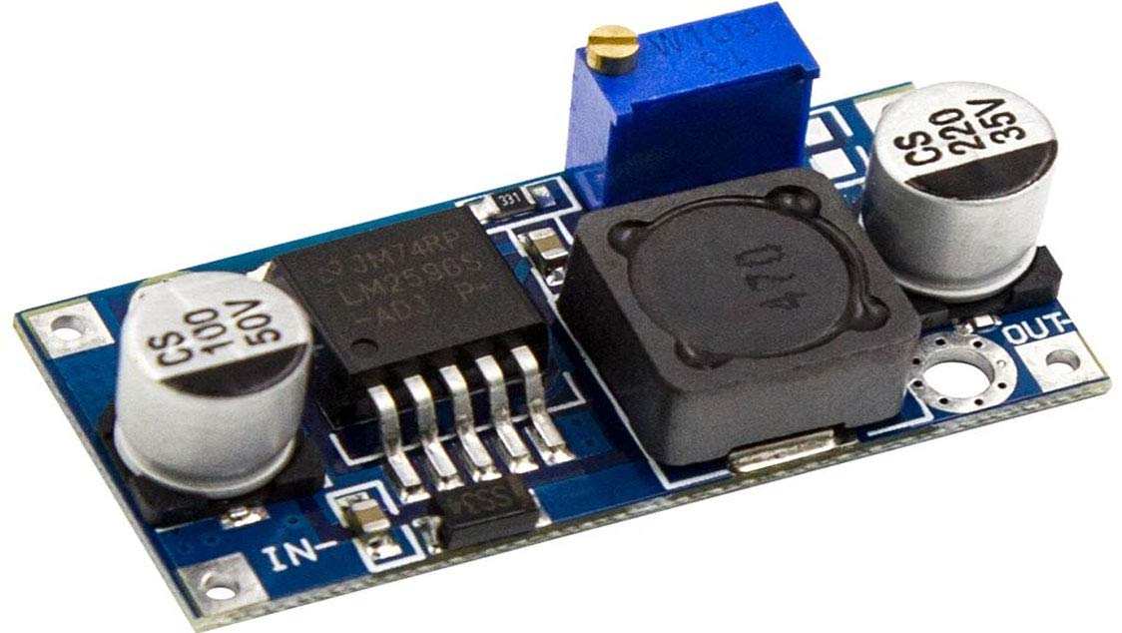
Fig :- Buck convertor 5v DC .

A buck converter, like the LM2596, is a device that takes a higher voltage and reduces it to a lower, stable voltage. For example, if you have a 12V or 24V power source but need 5V to power something like an Arduino or sensors, the LM2596 can convert that voltage down to exactly 5V.
Here’s how it works: You connect a higher voltage to the input of the converter, and it steps down the voltage to a lower level. In this case, you can set it to 5V. The LM2596 is efficient, meaning it doesn’t waste much energy as heat, so it’s good for projects where you need to save power. It can also provide a steady 5V even if the input voltage or the connected device’s power needs change.
In simple terms, the LM2596 buck converter lets you safely and efficiently use a higher voltage power source to power low-voltage devices, making it a useful tool for many electronics projects.

- SMPS Power supply .

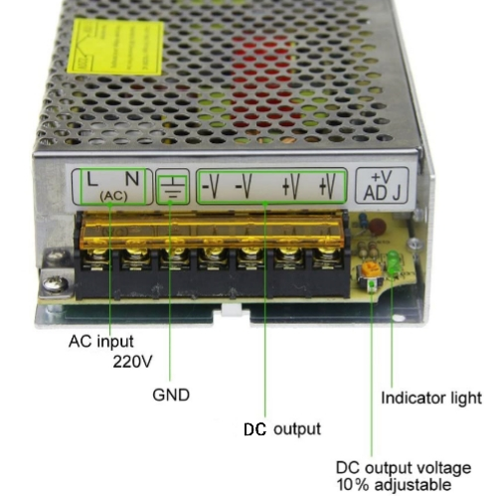
Fig:- Smps Power supply.

An SMPS (Switch Mode Power Supply) is a device used to convert electrical power from one form to another efficiently. It takes in high voltage, like the power from a wall socket, and converts it into the voltage needed to run your electronic devices, such as 12V or 5V.
The way it works is by rapidly turning the power on and off at a high speed, which helps control and reduce the voltage. After the voltage is lowered, it is smoothed out to provide a steady and stable output, ensuring your devices get the correct power they need.
In simple terms, an SMPS changes high voltage to a lower, usable voltage for devices like computers, chargers, or any electronic equipment, making sure they get the right amount of power.

4.Hardware Interfacing of Equipments.
4a) PWM Generator.

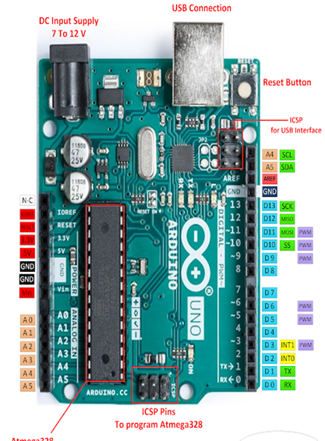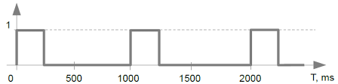
Pwm Generator from pin number 9..
A PWM (Pulse Width Modulation) generator on an Arduino Uno is used to control the power delivered to devices like motors, lights, and other components. It works by rapidly turning the power on and off, allowing you to control how much power a device receives without needing complex hardware.
For example, if you're controlling the brightness of an LED, the PWM signal switches the power on and off quickly. When the signal is on for more time than it's off, the LED appears brighter. When the signal is off more often, the LED dims. This method gives the illusion of smoothly varying power levels, even though the output is either fully on or off.
In a motor control scenario, the same principle applies. By adjusting how long the signal stays on compared to how long it stays off, you can control the speed of the motor. When the signal is on for most of the time, the motor runs faster. When it's off more often, the motor slows down.
Arduino Uno has a few specific pins designed for generating these signals, and the process is easy to implement in projects. This technique is widely used because it allows for efficient control of devices without wasting energy.
Fig:- PWM Generator Hardware connections.
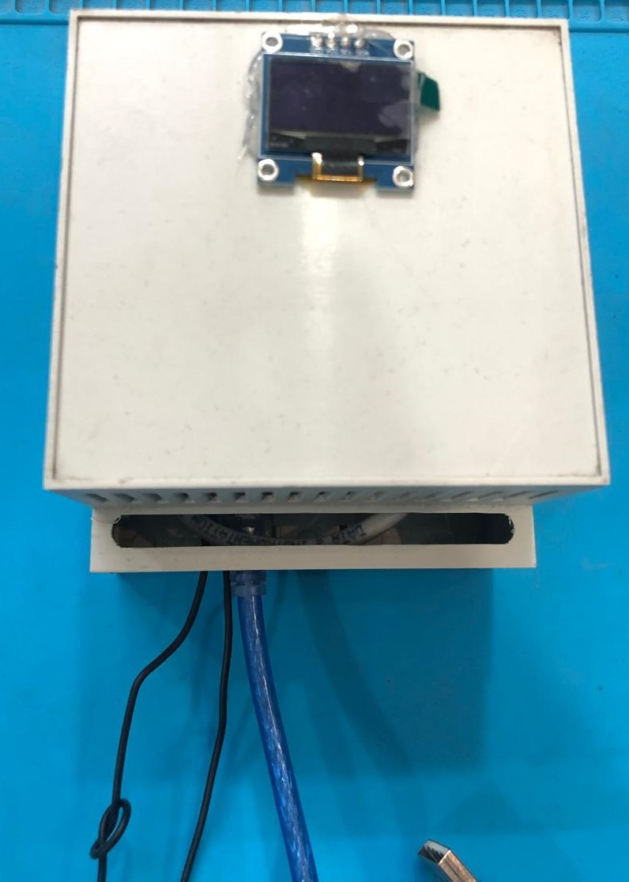

Pwm Generating pin

Ground pin
USB Connecting pin

Fig:- PWM Receiver Hardware connections.
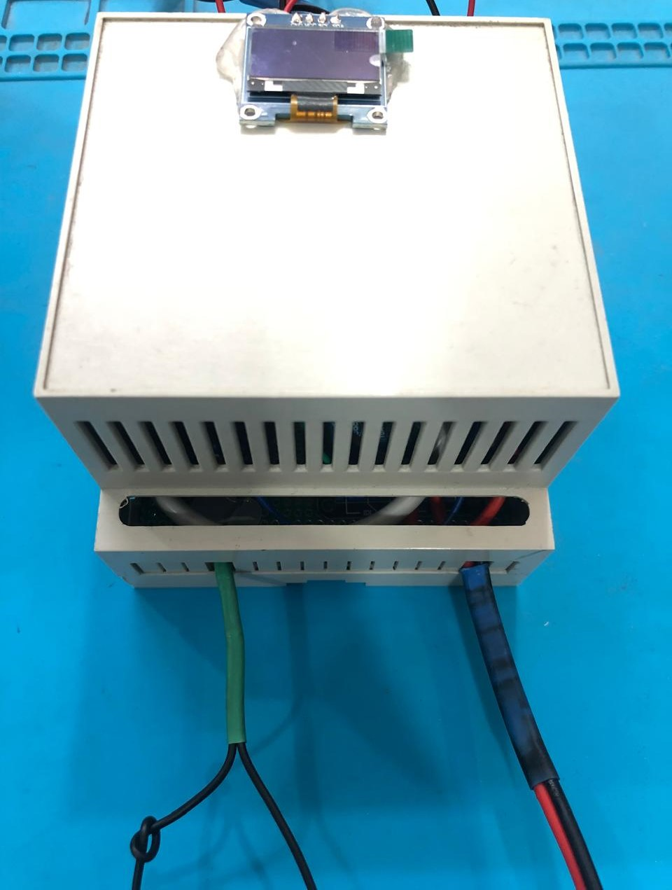

PWM Receiving pin.

Ground pin.
Explorer pin .

Fig:- Power Supply of PWM Receiver
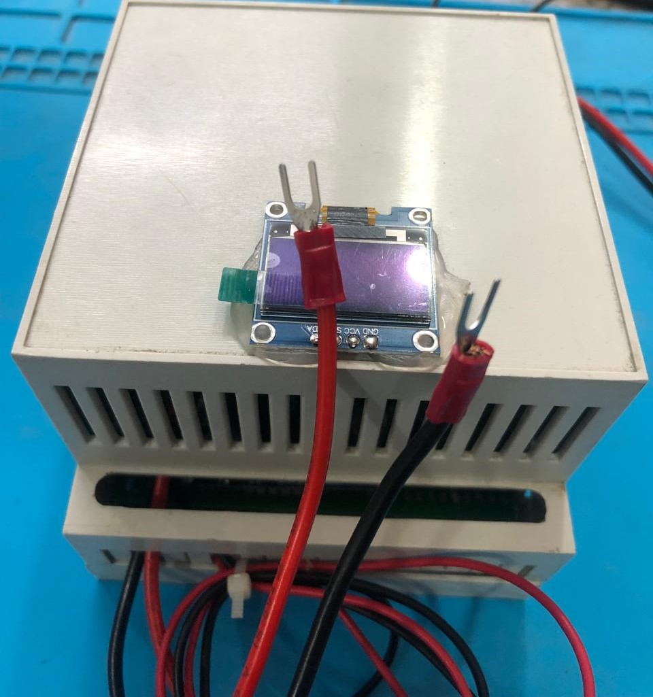

VCC 12v/18v pin.
Ground pin.

4b.) Fig:- Hardware interfacing of pwm generator and receiver.

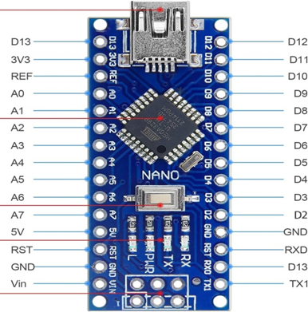

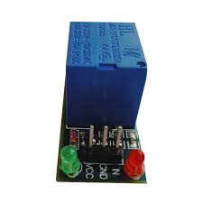
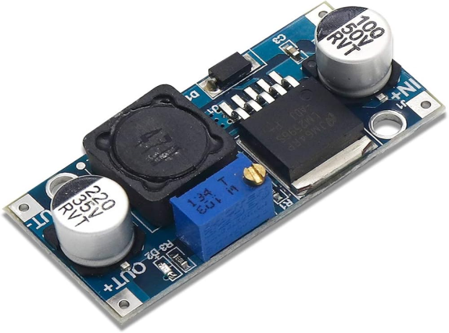Smps power supply as input.
5. PWM Output.
In this project, the PWM output from the Arduino Uno is used to control a relay based on the frequency it receives. When the frequency is between 2000 Hz and 3000 Hz, the relay is triggered to turn on. This means that if the frequency falls within this specific range, the relay will allow power to flow to whatever device it is controlling, like a motor or light.
If the frequency goes below 2000 Hz or above 3000 Hz, the relay will turn off, cutting off power to the device. This setup allows you to control the operation of the connected device based on the frequency signals received from the Arduino.
In simpler terms, the relay acts like a switch that only turns on when the frequency is between 2000 Hz and 3000 Hz, and stays off when the frequency is outside of that range. This method provides a way to safely manage power to devices based on specific frequency conditions.

